**Case Study-Titan Insurance Company**

The Titan Insurance Company has just installed a new incentive payment scheme for its lift policy sales force. It wants to have an early view of the success or failure of the new scheme. Indications are that the sales force is selling more policies but sales always vary in an unpredictable pattern from month to month and it is not clear that the scheme has made a significant difference.

Life Insurance companies typically measure the monthly output of a salesperson as the total sum assured for the policies sold by that person during the month. For example, suppose salesperson X has, in the month, sold seven policies for which the sums assured are £1000, £2500, £3000, £5000, £10000, £35000. X's output for the month is the total of these sums assured, £61,500. Titan's new scheme is that the sales force receives low regular salaries but are paid large bonuses related to their output (i.e. to the total sum assured of policies sold by them). The scheme is expensive for the company but they are looking for sales increases which more than compensate. The agreement with the sales force is that if the scheme does not at least break even for the company, it will be abandoned after six months.

The scheme has now been in operation for four months. It has settled down after fluctuations in the first two months due to the changeover. To test the effectiveness of the scheme, Titan have taken a random sample of 30 salespeople measured their output in the penultimate month prior to changeover and then measured it in the fourth month after the changeover (they have deliberately chosen months not too close to the changeover). The outputs of the salespeople are shown in Table

|  |  |  |
| --- | --- | --- |
| **Sales Agent Name** | **Old Sales** | **New Sales** |
| 1 | 57 | 62 |
| 2 | 103 | 122 |
| 3 | 59 | 54 |
| 4 | 75 | 82 |
| 5 | 84 | 84 |
| 6 | 73 | 86 |
| 7 | 35 | 32 |
| 8 | 110 | 104 |
| 9 | 44 | 38 |
| 10 | 82 | 107 |
| 11 | 67 | 84 |
| 12 | 64 | 85 |
| 13 | 78 | 99 |
| 14 | 53 | 39 |
| 15 | 41 | 34 |
| 16 | 39 | 58 |
| 17 | 80 | 73 |
| 18 | 87 | 53 |
| 19 | 73 | 66 |
| 20 | 65 | 78 |
| 21 | 28 | 41 |
| 22 | 62 | 71 |
| 23 | 49 | 38 |
| 24 | 84 | 95 |
| 25 | 63 | 81 |
| 26 | 77 | 58 |
| 27 | 67 | 75 |
| 28 | 101 | 94 |
| 29 | 91 | 100 |
| 30 | 50 | 68 |



**Case:**

As we can see from the distribution above the sales after the implementation of the scheme has increased for several agents whereas it has declined for others. This data needs to be statistically analyzed to infer the impact of the scheme on the company

**Analysis:**

To analyze this data and build a hypothesis this dataset was considered as normal because of central limit theorem. The number of samples that has been provided to us were 30 and sample sizes equal to or greater than 30 are considered sufficient for the central limit theorem to hold, meaning the distribution of the sample means is normally distributed. In addition, the samples were plot using R to verify the claim and were seen as normally distributed.

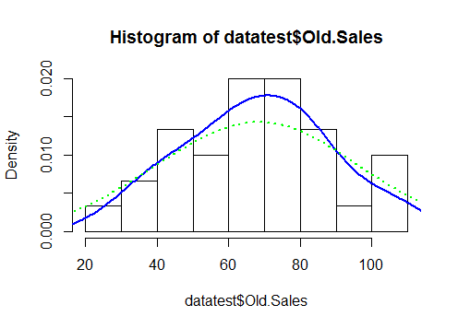

> hist(datatest$Old.Sales,probability = TRUE)

> lines(density(datatest$Old.Sales),col = "blue",lwd=2)

> lines(density(datatest$Old.Sales, adjust = 2),lty = "dotted", col = "green",lwd=2)

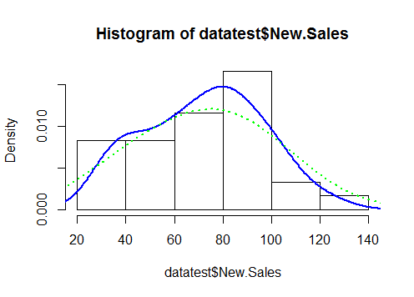

> hist(datatest$New.Sales,probability = TRUE)

> lines(density(datatest$New.Sales),col = "blue",lwd=2)

> lines(density(datatest$New.Sales, adjust = 2),lty = "dotted", col = "green",lwd=2)

**Stating the Hypothesis:**

Ho: µ1 ≤ µ2 (The mean sales are same before and after the campaign as Null hypothesis is always calculated at equality)

H1: µ1 > µ2 (The mean sales after implementing the scheme is greater than the mean sales before the scheme was implemented)

**Define the analysis mechanism:**

To analyze the hypothesis, we decided to perform a t-test: Paired samples for Mean. This test was adopted because the data samples shared are dependent as well as normally distributed.

**Analyzing the data:**

We used the Data analysis functionality of Excel to perform t test: Paired samples for Mean.

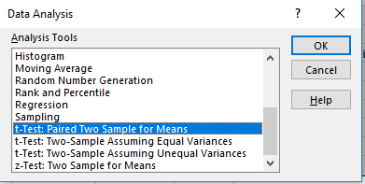

|  |  |  |
| --- | --- | --- |
| **t-Test: Paired Two Sample for Means** |  |  |
|  |  |  |
|  | ***New Sales*** | ***Old Sales*** |
| Mean | 72.03333333 | 68.03333333 |
| Variance | 578.9988506 | 418.4471264 |
| Observations | 30 | 30 |
| Pearson Correlation | 0.811801957 |  |
| Hypothesized Mean Difference | 0 |  |
| df | 29 |  |
| t Stat | 1.555914382 |  |
| P(T<=t) one-tail | 0.06528777 |  |
| t Critical one-tail | 1.699127027 |  |
| P(T<=t) two-tail | 0.13057554 |  |
| t Critical two-tail | 2.045229642 |  |

As we can see from the output t Critical one tail is coming out to be 1.6991 which is greater than t Stat 1.5559 (P value being 0.0652 > 0.05) the null hypothesis must be accepted. This hypothesis affirms that the new scheme was not incurring any profits to the company

**Redefining hypothesis:**

To reaffirm the output a new hypothesis was devised to check in case the average sales has decreased in after implementing the new scheme

Ho: µ1 = µ2 (The mean sales are same before and after the campaign)

H1: µ1 ≠ µ2 (The mean sales after implementing the scheme is different than the mean sales before the scheme was implemented)

For this hypothesis, also when we see the t Critical two tail it was coming out to be 2.04522 which again is greater than t Stat 1.5559 (P value being 0.1305 > 0.05) the null hypothesis must be accepted. This hypothesis affirms that the new scheme is not incurring loss to the company but is breaking even.

**Revalidating the results [1]:**

The results above were validated in R

> t.test(datatest$New.Sales,datatest$Old.Sales, alternative = "greater" ,paired = TRUE,conf.level = 0.95)

data: datatest$New.Sales and datatest$Old.Sales

t = 1.5559, df = 29, p-value = 0.06529

alternative hypothesis: true difference in means is greater than 0

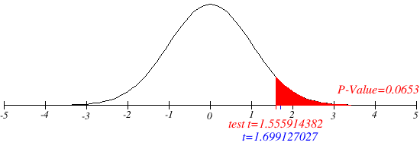

> t.test(datatest$New.Sales,datatest$Old.Sales, alternative = "two.sided" ,paired = TRUE,conf.level = 0.95)

data: datatest$New.Sales and datatest$Old.Sales

t = 1.5559, df = 29, p-value = 0.1306

alternative hypothesis: true difference in means is not equal to 0

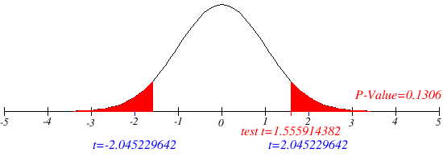

**Conclusion:**

* Conclusion of this hypothesis testing is that the new sales scheme have not impacted the sales figures of the enterprise. The mean sales have approximately remained the same even after 4 months of the scheme being implemented

**Recommendation:**

Our recommendation to the business is based on the below from the case study

* The scheme is expensive for the company but they are looking for sales increases which more than compensate.

**Recommendation**: Because of the scheme being not cost efficient and not resulting in sales increase the same can be stopped, if the company can no more wait.

* The agreement with the sales force is that if the scheme does not at least break even for the company, it will be abandoned after six months.

**Recommendation**: Because of agreement with the sales force that the scheme will be live if it atleast break even we can see from the tests above that it is breaking even, and could be inplace for few more months.

This decision will more be a business one and our recommendations as as above. Looking at the enterprise roadmap a business manager can take appropriate actions based on the above recommendation

1. To test this case study t test: Paired Sample of Means for inequality would have sufficed to reach a conclusion because Null hypothesis was being accepted and the mean difference is neither less than or more than zero